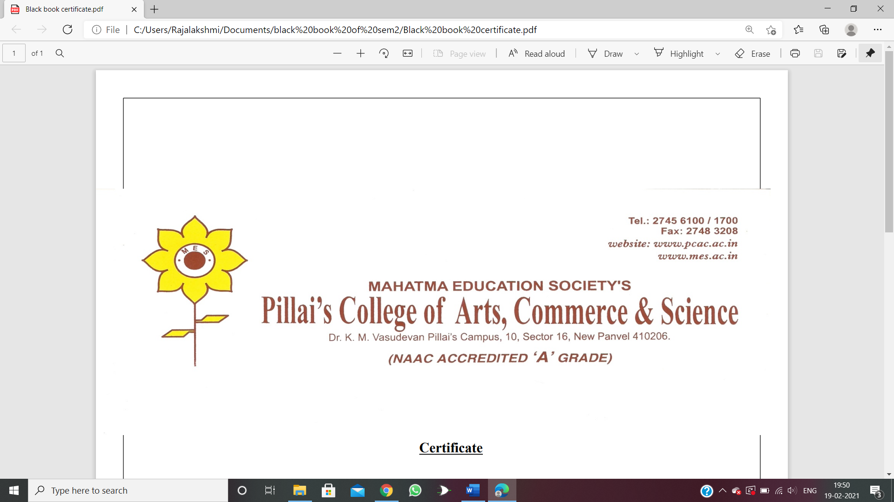

This is to certify that the project entitled “**TeacherLeave** ” is successfully completed by **Miss shraddha Vilas Dabade.** as per the syllabus and in partial fulfilment of continue assessment for the completion of BSc. degree in Computer Science of University of Mumbai, it is also to certify that this is the original work of the candidate done during the academic year: -2022-2023.

**Exam seat no: 8218**

**Place:**

**Date:**

**Signature of**

**Guide:**

**Signature of**

**Principal /Co-ordinator:**

**Signature of**

**External Examiner Seal:**

**Input**

**Department facecade.java**

package com.teacher;

import javax.ejb.Stateless;

import javax.persistence.EntityManager;

import javax.persistence.PersistenceContext;

@Stateless

public class DepartmentFacade extends AbstractFacade<Department> {

@PersistenceContext(unitName = "teacherleavePU")

private EntityManager em;

@Override

protected EntityManager getEntityManager() {

return em;

}public DepartmentFacade() {

super(Department.class);

}

}

**Leavefacade.java**

package com.teacher;

import javax.ejb.Stateless;

import javax.persistence.EntityManager;

import javax.persistence.PersistenceContext;

@Stateless

public class LeaveFacade extends AbstractFacade<Leave> {

@PersistenceContext(unitName = "teacherleavePU")

private EntityManager em;

@Override

protected EntityManager getEntityManager() {

return em;

} public LeaveFacade() {

super(Leave.class);

}

}

**Leavetype façade.java**

package com.teacher;

import javax.ejb.Stateless;

import javax.persistence.EntityManager;

import javax.persistence.PersistenceContext;

@Stateless

public class LeaveTypeFacade extends AbstractFacade<LeaveType> {

@PersistenceContext(unitName = "teacherleavePU")

private EntityManager em;

@Override

protected EntityManager getEntityManager() {

return em;

} public LeaveTypeFacade() {

super(LeaveType.class);

}

}

**Teacherfacade.java**

package com.teacher;

import javax.ejb.Stateless;

import javax.persistence.EntityManager;

import javax.persistence.PersistenceContext;

@Stateless

public class TeacherFacade extends AbstractFacade<Teacher> {

@PersistenceContext(unitName = "teacherleavePU")

private EntityManager em;

@Override

protected EntityManager getEntityManager() {

return em;

} public TeacherFacade() {

super(Teacher.class);

}

}

**Teacherleavefacade.java**

package com.teacher;

import javax.ejb.Stateless;

import javax.persistence.EntityManager;

import javax.persistence.PersistenceContext;

@Stateless

public class TeacherLeaveFacade extends AbstractFacade<TeacherLeave> {

@PersistenceContext(unitName = "teacherleavePU")

private EntityManager em;

@Override

protected EntityManager getEntityManager() {

return em;

}

public TeacherLeaveFacade() {

super(TeacherLeave.class);

}

}

**Index**

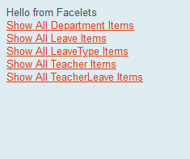

**Show all department**

**List**

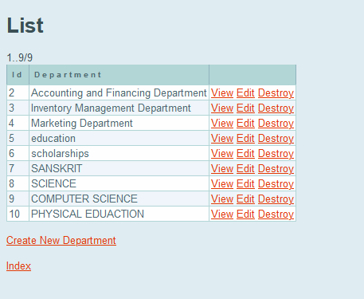

**Create new department**

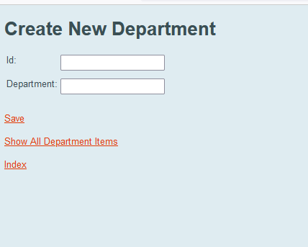

**Destroying department**

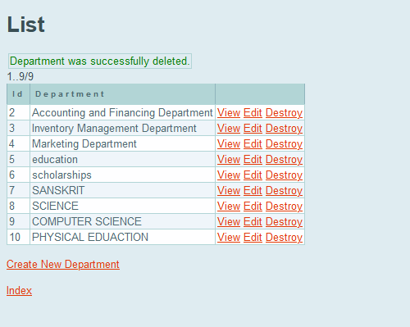

**Viewing department**

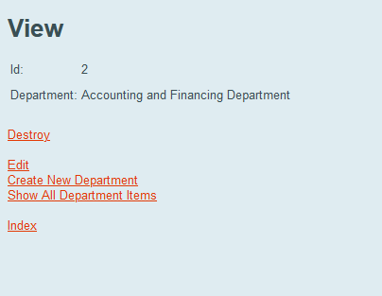

**Edit department**

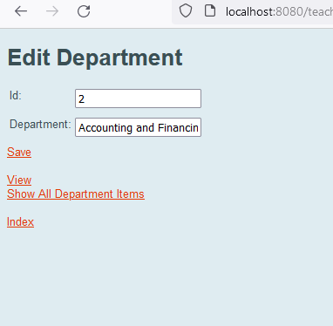

**Create new leave type or add new leave**

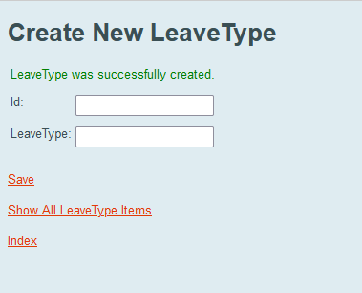

**List of all leave type**

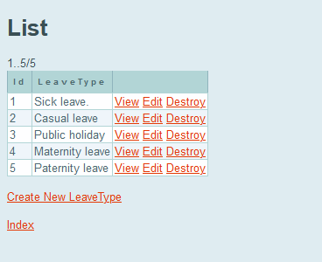

**View**

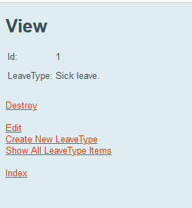

**Edit leave type**

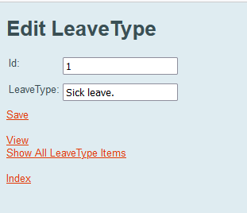

**Destroying leave type**

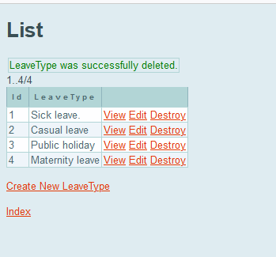

**Add new teacher**

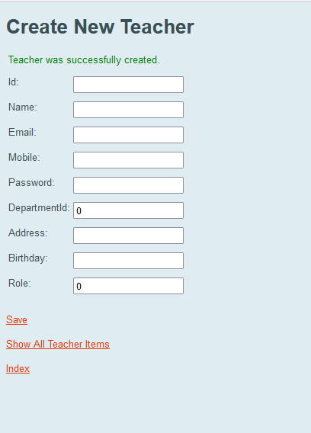

**List of teacher**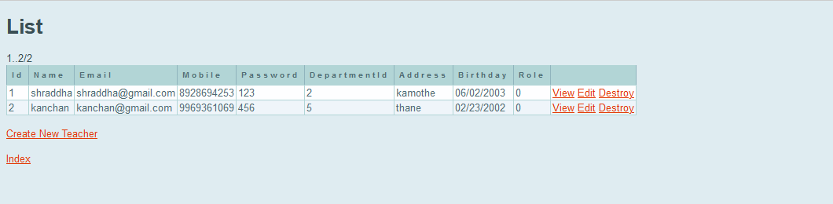

**View teacher**

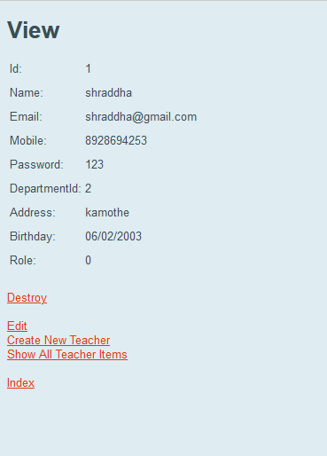

**Edit teacher**

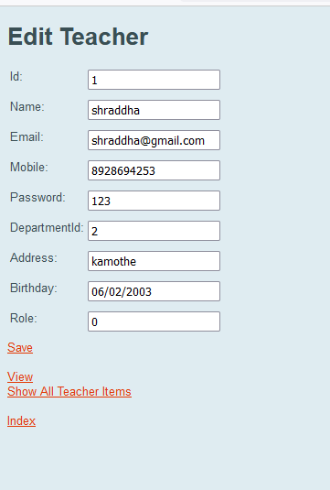

**Destroy teacher**

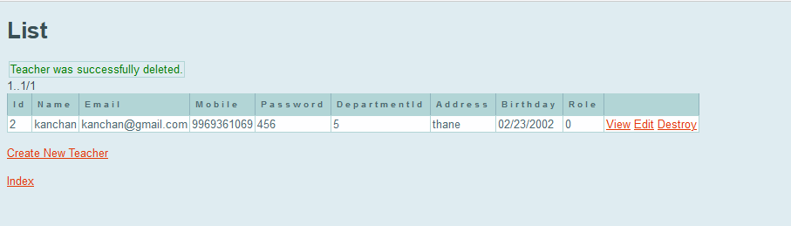

**Add teacher leave (for teacher)**

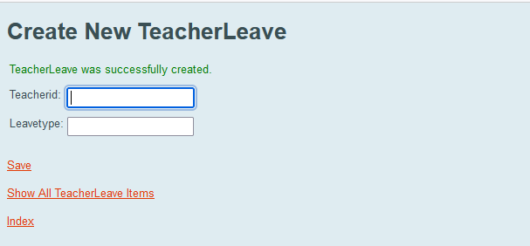

**List of teacher who having leave**

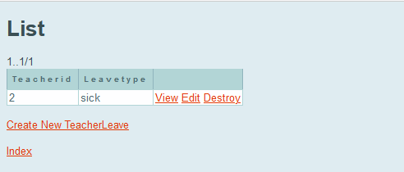

**View**

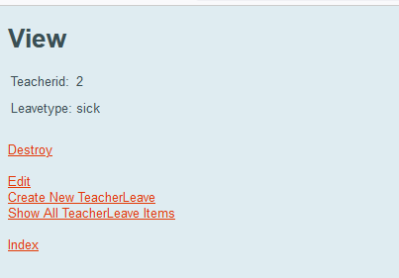

**Destroy**

